Installing and using the
PASMA Tower Inspection App

Information for tower operatives

PASMA is developing a new system that will help people across the world inspect towers in a consistent, thorough and smart way. We are taking part in a pilot study for this system, which means you’ll be using a mobile app to conduct and record tower inspections.

Install the app on your phone
This is a test version of the app, so installing it involves a few more steps than normal. But don’t worry, we’re here to talk you through it. Here’s what you need to do:

Android  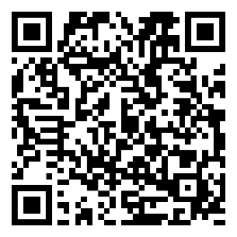 | - Scan the QR code or click this link: https://play.google.com/store/apps/details?id=co.uk.pasma.android  - Click the ‘install’ button  - Open the app and register for an account (following the on-screen instructions) using your work email address
iOS  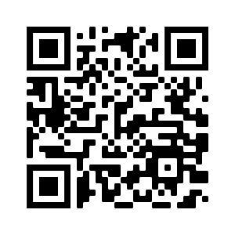 | - Scan the QR code or click the link to install TestFlight: https://testflight.apple.com/join/VXLMU6ym  - Once TestFlight is installed, click link again to download the PASMA app (‘accept’ invitation then ‘install’)  - Register for an account (following the on-screen instructions) using your work email address
Don’t forget to add your PASMA card details when you register your account!

How you’ll use the app

Join our organisation
We’ll invite you to ‘join our organisation’. Once you’ve accepted the invitation, the mobile app on your phone will be connected to our central inspection system.

Inspecting towers
Next time you inspect a tower, you won’t need to rely on your memory – the app has built-in, step-by-step inspection checklists to follow. There’s one for each configuration of tower you might build, such as cantilever towers or towers on stairways.
The app will prompt you to take photos of the tower. Make sure your photos clearly show the whole tower so if they wanted, a third-party – like someone back at the office – could look at them and determine if the tower has been built safely.
As you complete the process, you automatically create an electronic inspection record.
Display a PASMA Tower ID Card at the base of the tower. If the tower passed its inspection, the grey side should face outwards. If it’s not safe to use, display the red side instead.
You’ll get a reminder from the app when it’s time for a 7-day re-inspection.
Mark your towers as dismantled when you’re finished with them. The inspection record will still be stored safely in our central system, where it can’t get lost or damaged.

Using towers
Use the app to check if a tower is safe for use. You can see all the towers you’ll be working on or near – even if you didn’t build them – and their inspection status. Scan the QR code on the Tower ID Card for details.

Tower documentation
Hire & assembly companies only: The app will store important documentation for non-standard towers, such as design certificates, so you can always access them quickly and easily.

In the background
This is our opportunity to strengthen our inspection processes, to be surer than ever before that every tower across all our sites is built to the same high standards. During the pilot, we’ll be spot checking towers from the office. As a result, you might get a phone call or notification through the app telling you to stop work or asking you to re-inspect a tower. You can help to avoid this by following the inspection checklists carefully and taking clear photos of each structure.

Q&A

Where do I get PASMA Tower ID Cards?

PASMA has given us a supply to use during the pilot, so we’ll make sure you have a stock of them.

Can I keep using the app after the pilot?

Yes! Once the app is on your phone, we encourage you to use it whenever you build towers, whether that’s for us, other companies or at home. When you inspect towers for our organisation, a copy of the inspection record is stored centrally. That’s because we’ve connected your mobile app to our inspection system. If you use the app to inspect towers elsewhere, be sure to download PDF copies of your tower inspections. This is because you’re using a test version of the app that isn’t connected centrally. At some point, the real app will be launched to the public and you’ll be invited to switch over to that version.

What do I do if I find a bug or problem?

Please let PASMA know. That’s why there’s a pilot study taking place – it helps iron out any issues before the app is released more widely. PASMA will be very grateful to you for reporting bugs or problems as it gives them a chance to fix it. There’s a feedback form for reporting issues like this: ria-manual.pasma.co.uk/report-an-issue-or-bug

What if I have an idea for improving the app?

PASMA would love to hear it. Feedback from operatives like you, who use the app regularly to check their towers are safe, is invaluable. Your idea will be considered for future development. There’s a feedback form for suggestions and ideas: ria-manual.pasma.co.uk/report-an-issue-or-bug

How else can I give feedback?

We will ask for your feedback on the app, which will be shared with PASMA to help them fine tune the system ahead of its public launch. PASMA might also ask to arrange an interview with you.

What if I can’t install the app?

Please let us know if you have any problems installing the app on your phone.

Why do I need to use my work email address?

Once you’ve registered for an account, we’ll invite you to join our organisation. We’ll use your registered email address to generate the invitation, so need to know where to send it. That’s why it’s simplest if you use your work email, but you can use a different email if you let us know what it is.

